CSA1715 – ARTIFICIAL INTELLIGENCE
P.SAI SWETHA 192324011

LAB EXPERIMENTS:

EX – 3 :

Water Jug Problem
Aim
To solve the Water Jug Problem using Breadth First Search (BFS) in Python.
Algorithm
- Initialize two jugs with capacities 4L and 3L.
- Start with both jugs empty.
- Generate all possible operations:
  - Fill either jug.
  - Empty either jug.
  - Pour water from one jug to another.
- Store visited states.
- Repeat until the target amount is obtained.
- Display the sequence of states.

Code :
from collections import deque

def waterJug(cap1, cap2, target):
visited = set()
queue = deque()

queue.append((0, 0))

while queue:
x, y = queue.popleft()

if (x, y) in visited:
continue

visited.add((x, y))
print((x, y))

if x == target or y == target:
print("Target Achieved")
return

queue.append((cap1, y))
queue.append((x, cap2))
queue.append((0, y))
queue.append((x, 0))

transfer = min(x, cap2 - y)
queue.append((x - transfer, y + transfer))

transfer = min(y, cap1 - x)
queue.append((x + transfer, y - transfer))

waterJug(4, 3, 2)

output :

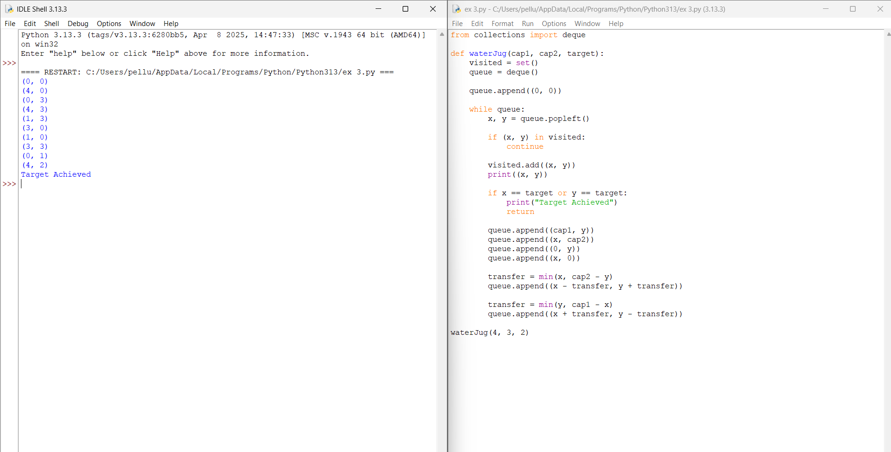

Result :
The Water Jug problem was successfully solved using the Breadth-First Search (BFS) algorithm. The program found the sequence of valid operations required to obtain the target quantity of water and displayed the solution path.

